practice: commands and arguments

Submitted By

**Thanuj Kumar S**

1. How many arguments are in this line (not counting the command itself). touch '/etc/cron/cron.allow' 'file 42.txt' "file 33.txt"

Answer: Three

1. Is tac a shell builtin command ?
2. Is there an existing alias for rm ?



1. Read the man page of rm, make sure you understand the -i option of rm. Create and remove a file to test the -i option.

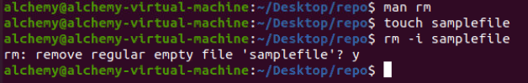

1. Execute: alias rm='rm -i' . Test your alias with a test file. Does this work as expected ?

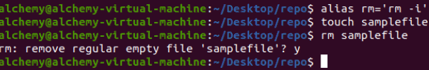

1. List all current aliases.

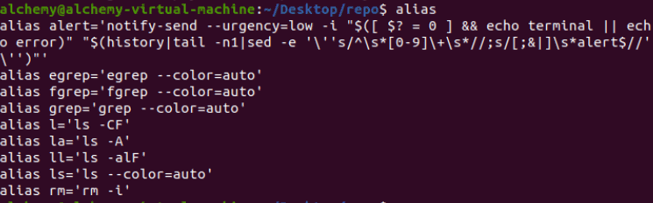

7a. Create an alias called 'city' that echoes your hometown.

7b. Use your alias to test that it works.

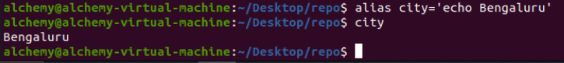

1. Execute set -x to display shell expansion for every command.

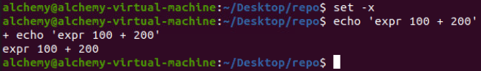

1. Test the functionality of set -x by executing your city and rm aliases.

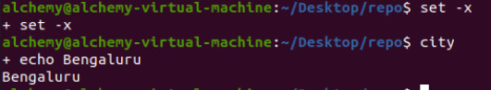

10 Execute set +x to stop displaying shell expansion.

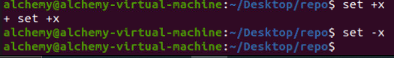

1. Remove your city alias.

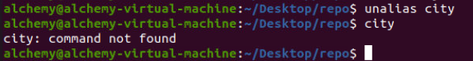

1. What is the location of the cat and the passwd commands ?

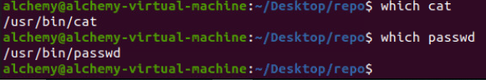

1. Explain the difference between the following commands:

echo

/bin/echo

**Answer:**

The echo command will be interpreted by the shell as the built-in echo command.

The /bin/echo command will make the shell execute the echo binary located in the /bin directory.

1. Explain the difference between the following commands: echo Hello

echo -n Hello

Answer: The -n option of the echo command will prevent echo from echoing a trailing newline.

echo Hello will echo six characters in total, echo -n hello only echoes five characters.

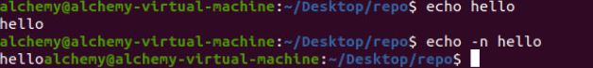

1. Display A B C with two spaces between B and C.



(optional)16. Complete the following command (do not use spaces) to display exactly the

following output:

4+4

10+14

=8

=24

1. Use echo to display the following exactly:

??\\



Find two solutions with single quotes, two with double quotes and one without quotes (and say thank you to René and Darioush from Google for this extra).

1. Use one echo command to display three words on three lines.

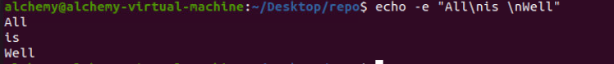

Submitted By

**Thanuj Kumar S**